September 2024

The Greenwich Historical Society invites you to participate in our 6th Annual *Festival of Tabletop Trees!* Continuing the tradition of past years, the festival will be featured (and promoted) as part of our Winter Festival.

We have attached this year’s participation form. The following are things you may want to know:

* We will supply a high quality 3ft. pre-lit artificial tree
* Please decorate & name your tree, representing your style
* Feel free to add additional lights if you feel your tree requires more
* Decorated trees need to be delivered to the Greenwich Historical Society between Fri., Dec. 1st and Mon., Dec. 4th by 4:30pm.
* Your tree will be judged for *Best in Show, Most Artistic, Most Traditional, Most Creative, Child-like* and *Most Whimsical*
* There will be an Opening Night Preview Party on Tues., December 5th from 5pm-7:30pm for all participants
* Your creation will be displayed in our museum lobby December 5thth-9th. Please feel free to invite your friends, family and associates to come visit and view your tree.
* A silent auction for the trees will take place during that time period. Bidding will end during our Annual Winter Festival on December 9th at 7pm. All proceeds directly benefit the Historical Society’s education programs.
* Please respond ASAP. This event has become extremely popular and space is limited. Don’t be left out!
* Lastly, enjoy the process and let your holiday spirit take over!

We hope you will consider joining us for this joyous holiday event and look forward to your response! Please send your participation form by as soon as possible to Kathy Stefanatos at museumstore@greenwichhistory.org, mail to 47 Strickland Road, Cos Cob, CT 06807 or come and visit our campus and drop it off. We’d love to see you!

Sincerely,

Barbara Johann

Museum Store Manager



**Participation Form**

2024 Annual Festival of Trees December 6th -9th

Thank you for your participation in the Greenwich Historical Society Festival of Tabletop Trees! Please fill out the following information and return to the address listed below or e-mail to [museumstore@greenwichhistory.org](mailto:museumstore@greenwichhistory.org) no later than 11/14/24.

Name of Organization:

Contact Name (s):

Address:

City/State/Zip:

Telephone:

**E-Mail**:

*(We will be sending all confirmations out via email only.)*

Description of your Tabletop Tree Theme Example: Children’s, Christmas, Vintage etc.

____________________________________________________________________________________

**Information for Signage**: Please tell us exactly how you wish your name to appear on signage.

Name(s) of Contributor:

**Title of Tree**: __________________________________

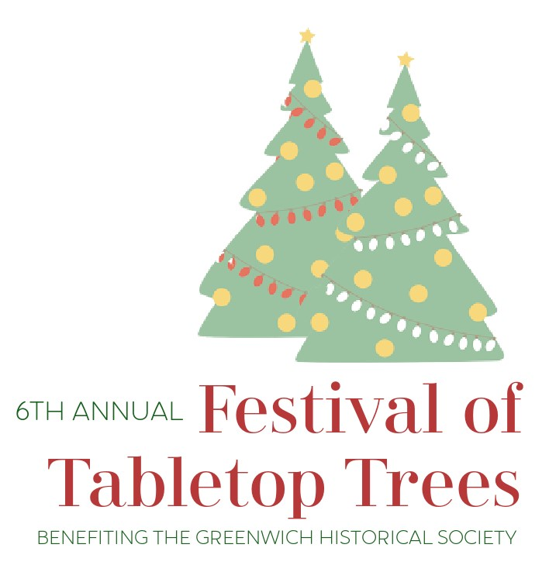*Please feel free to be creative and have fun with it! When available trees can be picked up in the museum lobby.*

PLEASE SUBMIT COMPLETED FORM BY NOV. 14TH TO:

Greenwich Historical Society

Attn: Kathy Stefanatos, 47 Strickland Road, Cos Cob, CT 06807 or e-mail to [museumstore@greenwichhistory.org](mailto:museumstore@greenwichhistory.org).

Thank you for your participation. Trees can be delivered from Fri., Dec. 1st-4th but **MUST** be delivered **NO LATER** than Monday, Dec 4th by 4:30 pm.